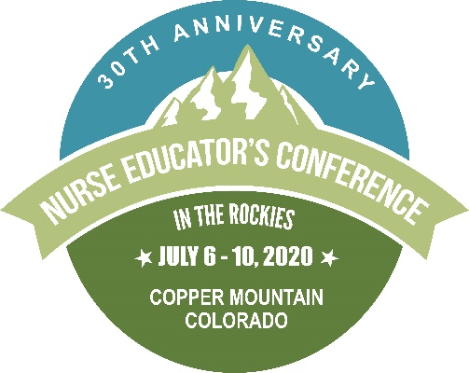
2020 NEC in the Rockies
July 6 – 10, 2020
Copper Mountain Colorado

Exhibitor Opportunities

Who Should Exhibit?
- Vendors offering innovative nursing education tools or specializing in nursing products
- Book and software publishers
- Educational programs and institutions
- Nursing product or apparel companies

Benefits of Exhibiting
- Dedicated exhibit hours where the nurse educators literally come to you!
- Chance to network with hundreds of nurse educators and decision-makers from across the country at the Networking Receptions.
- Publication of your company name and logo in the program and in marketing materials.
- Online listing and link to your company website.

Exhibitor Bingo
Encourage attendees to visit your exhibit booth by participating in exhibitor bingo. Each attendee will receive a “bingo” card at registration with a square for each participating exhibitor. When attendees visit your booth, you will mark their card with a stamp or initials. Once an attendee’s card has been marked by all exhibitors, they will be entered into a raffle. Don’t forget to Bring a Prize for Bingo!! Each participating exhibitor must submit a prize valued at $25 or more for the raffle upon arrival at the conference.

Conference Dates
The Nurse Educators Conference in the Rockies will start with preconferences on Monday, July 6th. Preconferences continue on Tuesday, July 7th, and the full conference starts on Wednesday, July 8th and wrap up on Friday, July 10th at lunch.

Specific Exhibitor Hours
Wednesday, July 8th Must be set up by 8:00 am
Specific Hours: 8:30 – 9:30 am
4:15 – 6:15 pm
Networking: 6:30 – 7:30 pm
Thursday, July 9th Specific Hours: 11:15 – 12:45 pm
4:00 – 5:30 pm
Networking: 5:30 – 7:00 pm
Break down: By 11:00 am Friday, July 10^{th.} Can break down and depart on Thursday evening if desired.

Nurse Educator’s Conference in the Rockies
Exhibitor
Nonprofit: $700*, For-Profit: $800*

- Recognition in printed program, Facebook and contact emails
- Recognition on website with company logo
- One conference registration for meals (additional meal tickets can be purchased online)
- Tickets for both receptions
- 6’ skirted exhibit table– on display for full Conference
- Free internet onsite
* If received before June 14, 2020. After June 14, 2020, prices will increase $100.

